Ethereum Consortium

Single Member Multi Region

Contents

Overview 3

About blockchain 3

Mining Node Details 3

Transaction Node Details 4

Deployment Architecture 4

Description 4

Getting Started 4

Post Deployment Sanity Checks 12

Administrator page 12

Accessing Nodes 15

Peer Info Registrar 15

# Overview

This solution template is designed to make it sufficiently easier and quicker to deploy and configure a multi-member consortium Ethereum network with minimal Azure and Ethereum knowledge.

With a handful of user inputs and a single-click deployment through the Azure portal, each member can provision their network footprint, using Microsoft Azure compute, networking, and storage services across the globe. Each member's network footprint consists of a set of load-balanced transaction nodes with which an application or user can interact to submit transactions, a set of mining nodes to record transactions, and a VPN gateway. A subsequent connection step connects the gateways to create a fully configured multi-member blockchain network.

# About blockchain

For those of you who are new to the blockchain community, the release of this solution is a great opportunity to learn about the technology in an easy and configurable manner on Azure. However, to get started, we recommend deploying the simpler Ethereum consortium network topology with this guided walkthrough, before building out multi-member networks.

## Mining Node Details

We have explicitly separated the nodes that mine transactions from the nodes that accept transactions to ensure that the two actions are not competing for the same resources.

A consortium member can provision up to 5 regions containing one or more mining nodes, backed by a managed disk. One or more nodes in the region is configured as a boot node to support dynamic discoverability of the nodes in the network. Mining nodes communicate with other mining nodes to come to consensus on the state of the underlying distributed ledger. There is no need for your application to be aware of or communicate with these nodes. Since we are focusing on private networks, the mining nodes are isolated from inbound public internet traffic to add a secondary layer of protection. Outbound traffic is allowed, but not to the Ethereum discovery port.

All nodes have a stable version of the Go Ethereum (Geth) client and are configured to be mining nodes. If you did not supply a custom genesis block, all nodes use the same Ethereum address and key pair that is protected by the Ethereum account password. The Ethereum passphrase you provided is used to generate the default account (coinbase) for each mining node. As mining nodes, mine, they collect fees that are added to this account.

The number of mining nodes per consortium member depends on the overall size of the network desired and the amount of hashing power dedicated to each member. The larger the network, the more nodes that need to be compromised to gain an unfair advantage. The template supports up to 15 mining nodes per region provisioned using virtual machine scale sets.

## Transaction Node Details

A consortium member also has a set of load-balanced transaction nodes. These nodes are reachable from outside the virtual network, so that applications can use these nodes to submit transactions or execute smart contracts within the blockchain network. All nodes have a stable version of the Go Ethereum (Geth) client and are configured to maintain a complete copy of the distributed ledger. If a custom genesis block is not provided, these nodes use the same Ethereum account, protected by the Ethereum account password.

We have load-balanced the transaction nodes within an availability set to maintain high availability. The template supports up to 5 transaction nodes provisioned using virtual machine scale sets.

# Deployment Architecture

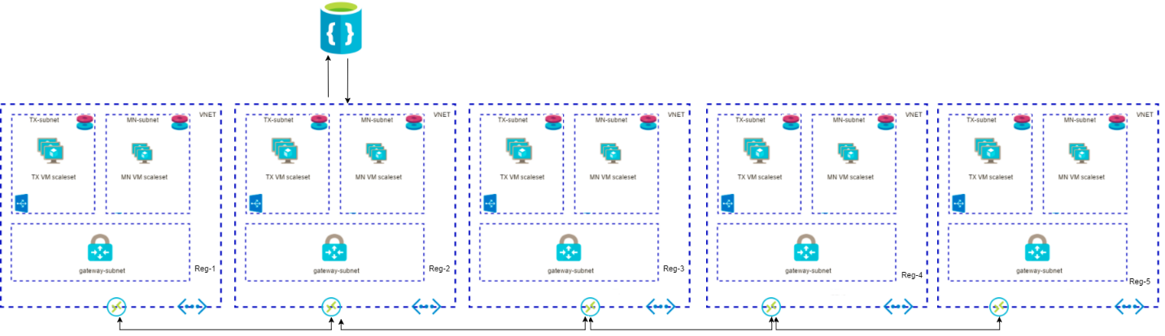

## Description

This solution template can deploy single or multi region based multi member Ethereum consortium network, the virtual network of each region is connected to other region in a chain topology using the VNET gateways and connection resources. Each VNET gateway connects to other using connections resource. It also provisions a registrar which contains required information of all the Miner and Transaction nodes deployed in each region.

# Getting Started

This process requires an Azure subscription that can support deploying several virtual machines scale sets and managed disks. If necessary, [create a free Azure account](https://azure.microsoft.com/en-us/free/) to begin.

Once a subscription is secured, go to Azure portal. Select ‘+’, Marketplace (‘See all’), and search for ‘Ethereum single member multi region’.

The Template Deployment will walk you through configuring the first member’s footprint in the network. The deployment flow is divided into three steps: Basics, Deployment regions, Network Configurations, Ethereum configuration and Registrar configuration.

**Basics**

Under the ‘Basics’ blade, specify values for standard parameters for any deployment, such as subscription, resource group and basic virtual machine properties.

A detailed description of each parameter follows:

|  |  |  |  |
| --- | --- | --- | --- |
| **Parameter Name** | **Description** | **Allowed Values** | **Default Values** |
| Resource Prefix | String used as a base for naming resources (4 alphanumeric characters or less). A unique hash is prepended to the string for some resources, while resource-specific information is appended. | Alphanumeric characters with length 4 | NA |
| VM user name | Administrator username of each deployed VM (alphanumeric characters only) | 1-64 characters | gethadmin |
| Authentication type | The method to authenticate to the virtual machine. | Password or SSH public key | Password |
| Password (Authentication type = Password) | The password for the administrator account for each of the virtual machines deployed. The password must contain 3 of the following: 1 upper case character, 1 lower case character, 1 number, and 1 special character.  While all VMs initially have the same password, you can change the password after provisioning. | 12 -72 characters | NA |
| SSH Key (Authentication type = Public Key) | The secure shell key used for remote login. |  | NA |
| Subscription | The subscription to which to deploy the consortium network |  | NA |
| Resource Group | The resource group to which to deploy the consortium network. |  | NA |
| Location | The Azure region for resource group. |  | NA |

**A sample deployment is shown below**

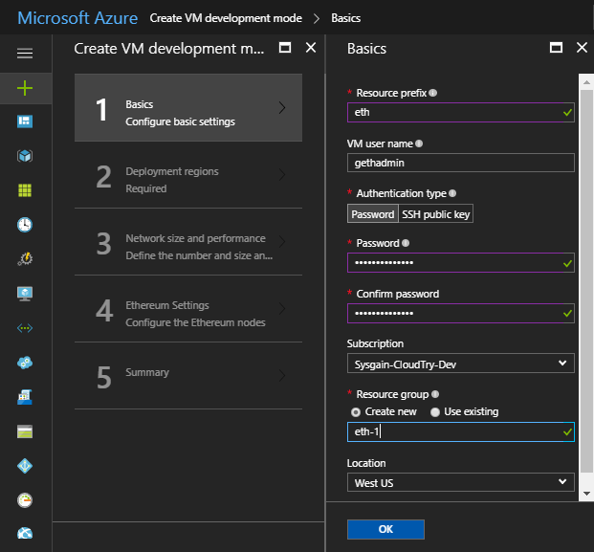

**Deployment regions**

Next, under Deployment regions, specify inputs for Number of region(s) to deploy the consortium network and selection of Azure regions based on the number of regions given. User can deploy in maximum of 5 regions.

A detailed description of each parameter follows:

|  |  |  |  |
| --- | --- | --- | --- |
| **Parameter Name** | **Description** | **Allowed Values** | **Default Values** |
| Number of region(s) | Number of Regions to deploy the consortium network | 1, 2, 3, 4, 5 | NA |
| First region | First region to deploy the consortium network | All the allowed region by azure | West US |
| Second region | Second region to deploy the consortium network (Visible only when number of region is selected as 2) | All the allowed region by azure | East US |
| Third region | Third region to deploy the consortium network (Visible only when number of region is selected as 3) | All the allowed region by azure | Central US |
| Fourth region | Fourth region to deploy the consortium network (Visible only when number of region is selected as 4) | All the allowed region by azure | East US 2 |
| Fifth region | Fifth region to deploy the consortium network (Visible only when number of region is selected as 5) | All the allowed region by azure | West US 2 |

**A sample deployment is shown below:**

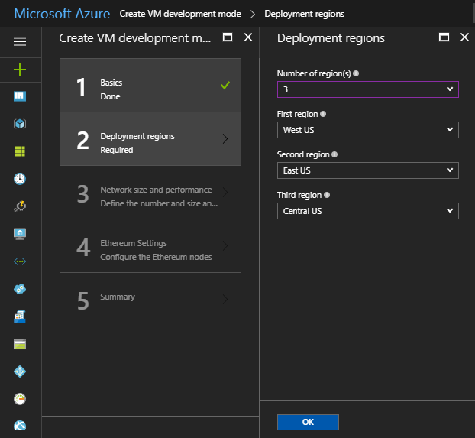

**Network size and performance**

Next, under ‘Network size and performance’ specify inputs for the size of the consortium network, such as number and size of mining nodes and transaction nodes.

A detailed description of each parameter follows:

|  |  |  |  |
| --- | --- | --- | --- |
| **Parameter Name** | **Description** | **Allowed Values** | **Default Values** |
| Consortium Member ID | The ID associated with each member participating in the consortium network used to configure IP address spaces to avoid collision.    Member ID should be unique across different organizations in the same network. A unique member ID is needed even when the same organization deploys to multiple regions.    Make note of the value of this parameter, since you will need to share it with other joining members. | 0-255 | 0 |
| Number of mining nodes | The number of mining nodes deployed per region | 2-15 | 2 |
| Mining node storage performance | The type of managed disk backing each of the deployed mining nodes. | Standard or Premium | Standard |
| Mining node virtual machine size | The virtual machine size used for mining nodes. | Standard A, Standard D, Standard D-v2, Standard F series, Standard DS, and Standard FS | Standard_A1 |
| Number of load balanced transaction nodes | The number of transaction nodes to provision as part of the network. | 1-5 | 2 |
| Transaction node storage performance | The type of managed disk backing each of the deployed transaction nodes. | Standard or Premium | Standard |
| Transaction node virtual machine size | The virtual machine size used for transaction nodes. | Standard A, Standard D, Standard D-v2, Standard F series, Standard DS, and Standard FS | Standard_A1 |

**A sample deployment is shown below:**

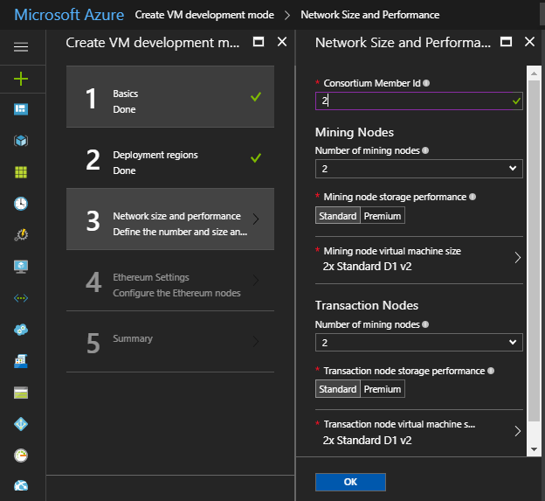

**Ethereum Settings**

Next, under Ethereum settings, specify Ethereum-related configuration settings, like the network ID and Ehterum account password or genesis block.

A detailed description of each parameter follows:

|  |  |  |  |
| --- | --- | --- | --- |
| **Parameter Name** | **Description** | **Allowed Values** | **Default Values** |
| Ethereum Network ID | The network ID for the consortium Ethereum network being deployed. Each Ethereum network has its own Network ID, with 1 being the ID for the public network. While we have restricted network access for mining nodes, we still recommend using a large number to prevent collisions. | 5 - 999,999,999 | 10101010 |
| Custom genesis block | Option to either automatically generate a genesis block or provide a custom one. | Yes/No | No |
| Ethereum Account Password  (Custom genesis block = No) | The administrator password used to secure the Ethereum account imported into each node.  The password must contain the following: 1 upper case character, 1 lower case character, and 1 number. | 12 or more characters | NA |
| Ethereum private key passphrase (Custom genesis block = No) | The passphrase used to generate the ECC private key associated with the default Ethereum account that is generated. A pre-generated private key does not need to be explicitly passed in.    Consider a passphrase with sufficient randomness to ensure a strong private key and no overlap with other consortium members. The passphrase must contain the following at a minimum: 1 upper case character, 1 lower case character, and 1 number.    Note if two members use the same passphrase the accounts generated will be the same. This is useful if a single organization is trying to deploy across regions and wants to share a single account (coin base) across all nodes. | 12 or more characters | NA |
| Genesis block (Custom genesis block = Yes) | JSON string representing custom genesis block. You can find more details on the format of the genesis block here, under Custom Networks.    An Ethereum account is still created when providing a custom genesis block. You should still consider specifying a prefunded Ethereum account in the genesis block to not wait for mining. | Valid JSON | NA |
| Shared Key for Connection | A Shared key for connection between VNET gateways. | 12 or more characters | NA |

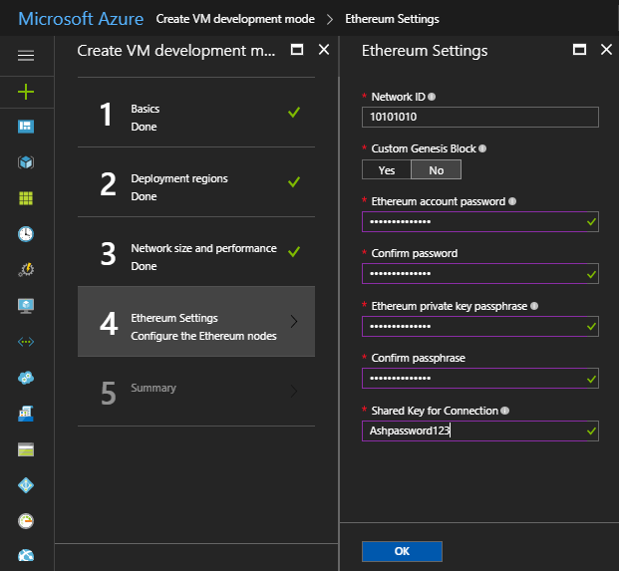

**Summary**

Click through the summary blade to review the inputs specified and to run basic pre-deployment validation.

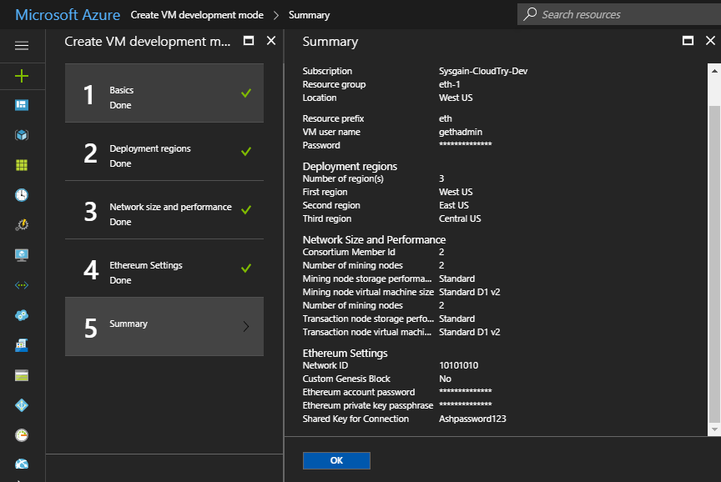

Review legal and privacy terms and click ‘Purchase’ to deploy. This template pre-deploys the necessary VPN Gateways to support network connectivity with other members. Deployment of the gateway can take up to 45 to 50 minutes.

# Post Deployment Sanity Checks

## Administrator page

Once the deployment has completed successfully and all resources have been provisioned, you can go to the administrator page to get a simple view of your blockchain network and sanity check the deployment state. The URL of the admin page is the DNS name of the load balancer; it is also the first output of the template deployment.

To find it, select the resource group that was just deployed. Then, select Overview, and click on the link immediately under Deployments that shows the number that succeeded.

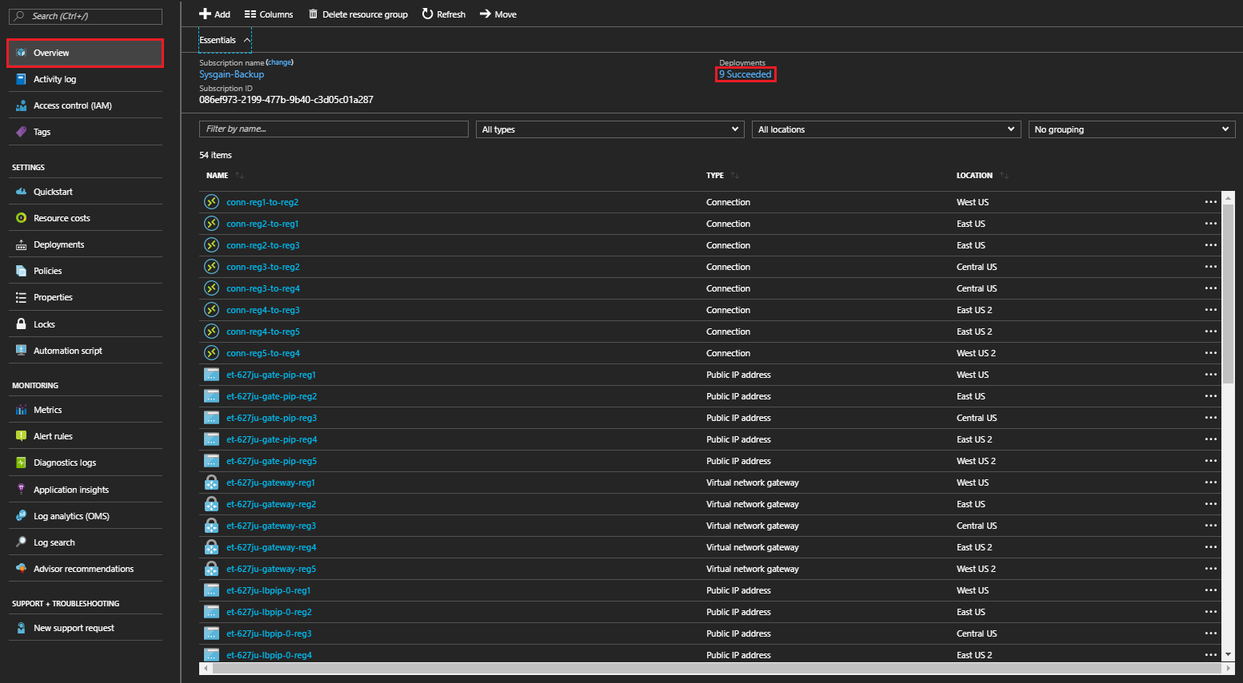

The new screen shows deployment history. Select the first template ‘microsoft-azure-blockchain.azuremulti…’ and look for the ‘Outputs’ section in the lower half of the screen. You’ll see the URL for the admin page listed as the first output parameter.

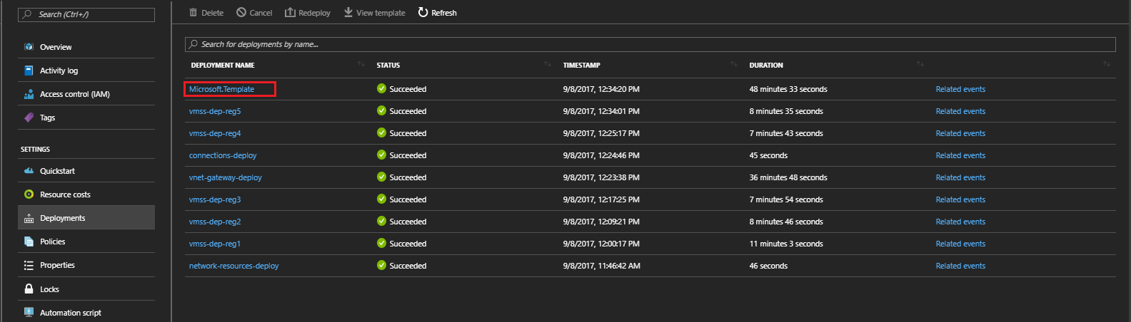

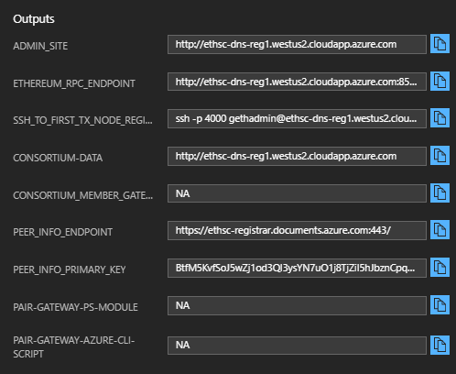

To get to the admin page, copy the ‘ADMIN-SITE’ output and open it in another tab.

On the admin page, you can get a high-level overview of the topology you just deployed by reviewing the Ethereum Node Status section. It includes all node hostnames, their peer count, and the latest block seen. The peer count for each node is the minimum of (total node count – 1) and twenty-five, where twenty-five is the configured maximum peer count. Note, that the peer count does not restrict the number of nodes that can be deployed within the network. Occasionally, you will see the peer count fluctuate and be less than the (total number of nodes -1). The difference in the count is not always a sign that the nodes are unhealthy, since forks in the ledger can cause minor changes in peer count. Finally, you can inspect the latest block seen by each node in the network to determine forks or lags in the system.

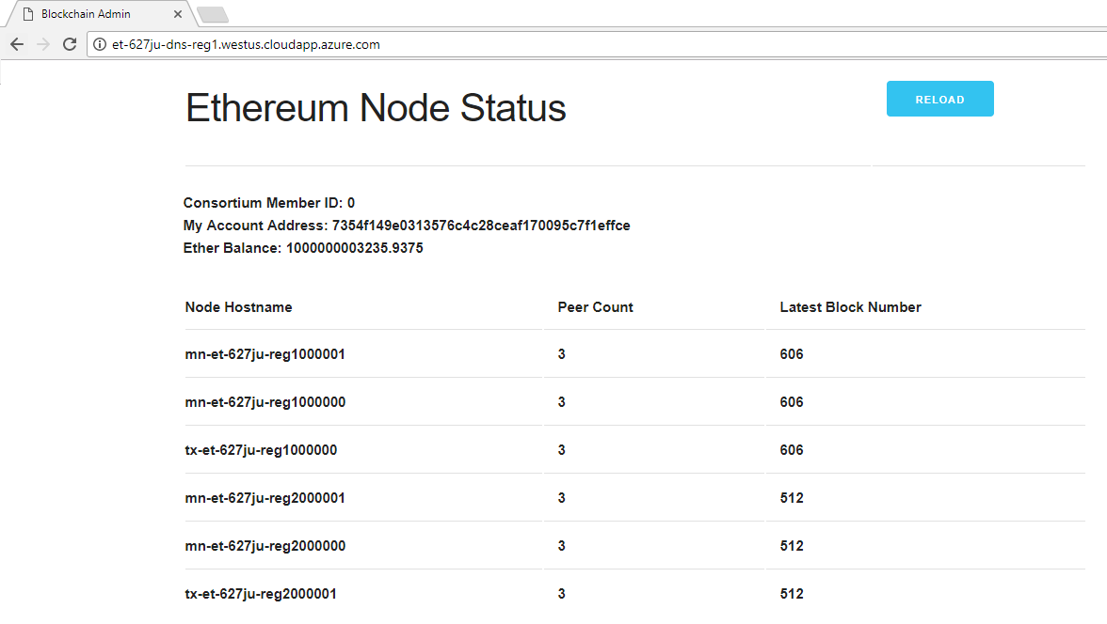

The node status is refreshed every 10 seconds. Reload the page via the browser or "Reload" button to update the view.

## Accessing Nodes

You can remotely connect to the virtual machines for the transaction nodes via SSH with your provided admin username and password/SSH key. Since the transaction node VMs do not have their own public IP addresses, you will need to go through the load balancer and specify the port number. The SSH command to run to access the first transaction node is the third template output, ‘SSH-TO-FIRST-TX-NODE-REGION1’ (for the sample deployment: ssh -p 4000 gethadmin@leader4vb.eastus.cloudapp.azure.com). To get to additional transaction nodes, increment the port number by one (e.g. the first transaction node is on port 4000).

Since the virtual machines on which the mining nodes run are not externally accessible, you will need to go through one of the transaction nodes. Once you have SSH’ed into a transaction node, install your private key on the transaction node or use your password to SSH into any of the mining nodes.

## Peer Info Registrar

This solution includes a Peer information registrar resources which stores details of all the nodes present in each consortium member, important details like hostname, private IP address, consortium ID’s of transaction nodes, boot node URLs etc. You can navigate to the Peer info registrar resource and view all the documents in the Collection present in the registrar.

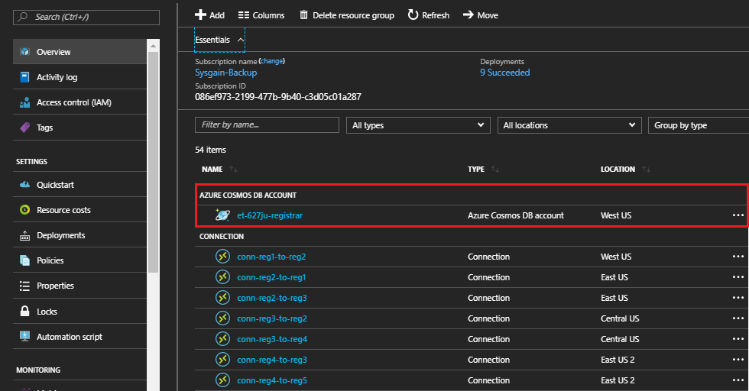

Navigate to the collection present inside the Peer info registrar.

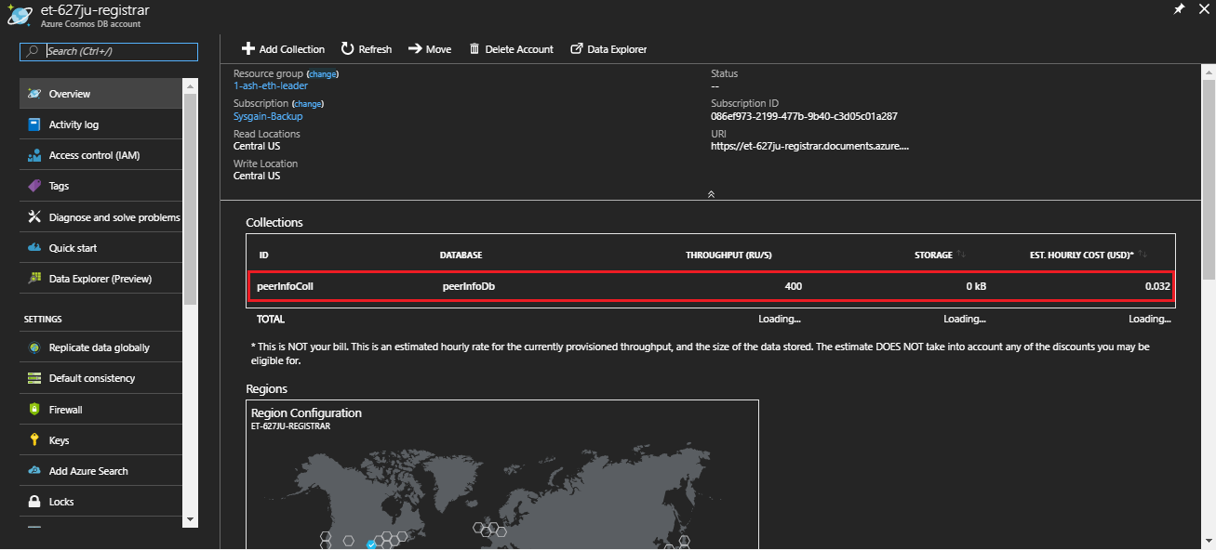

Here details of each node present in this consortium member is stored as documents.

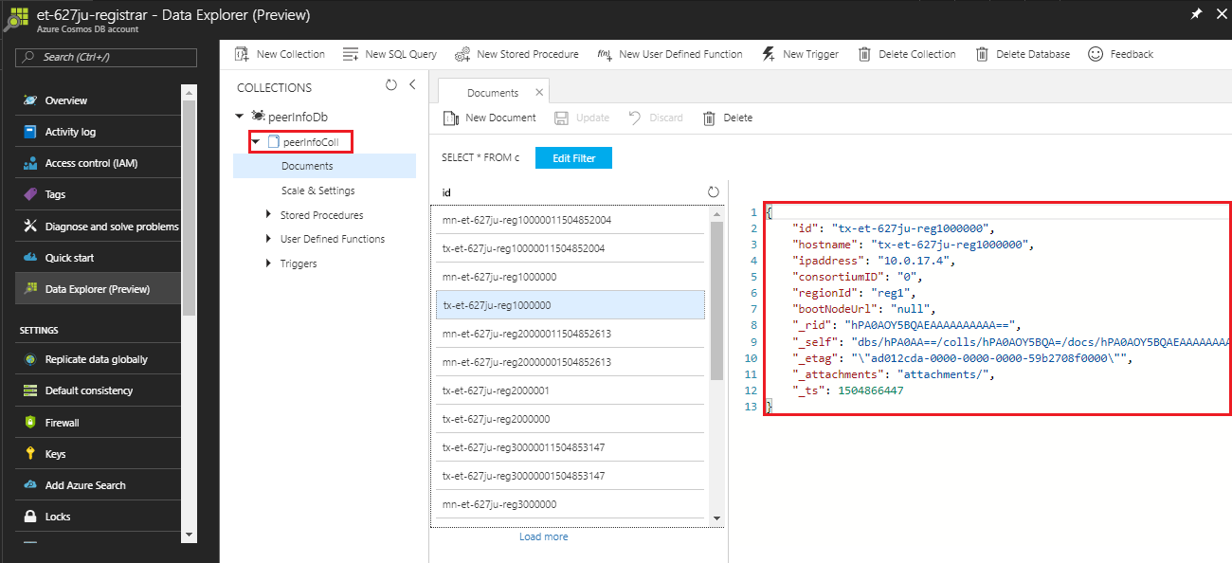

These are few ways in which you can do post deployment sanity check.